It's not super hard to find good quality seats on the web, but it can be intimidating if you're ordering something this expensive online. Until I did a lot of research on these products, I actually realized how feasible it actually is.
If you read reviews on most high quality chairs, almost everyone had a good experience with delivery and set up even though they also were concerned about having such a large item shipped.

Table of Contents
Under $1000
$1000 - $2000
$2000+
Other Home Theater Resources

Things to Consider Before You Buy
- How firm do you want the seats to be? Do you want to sink into it? Some people like sinking straight into a seat and some don't. Just because a seat looks like it can do that for you doesn't mean it actually will. If you really care about it, most reviews will describe how much you sink into a particular seat.
- How hard is it to assemble and do you have space to actually get it through? It sucks, but some people reviewed their experience and weren't able to move it into parts of their basement or fit their seats in a good position.
- Make sure you have enough wall away recline space. A mouthful to pronounce, but the graphic below will help you understand what I'm talking about
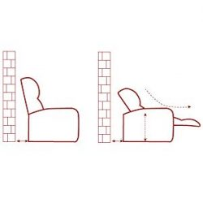
Some seats will require more and some seats will require less...just something to think about. You don't want to wedge a seat right up against a wall so make sure you can afford a little extra space if you have a small set up.
*The best chairs will have reviews from people who have had them longer than a year. You definitely want durability to be in the top considerations since it's likely you're going to spend a grand or more on seats you want to last a long time.

Price range $under 1000
I found ones that stood out to me the most which were based on comfort and common sense. Check out the bottom of this article to see some more resources on other home theater seating websites. If you have any questions or anything feel free to leave a comment or reach out at entertainmentden.ns@gmail.com and I'll do my best to respond.

Homall Gaming Chair

$130
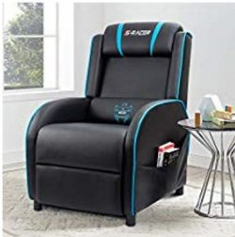
This one goes for about $130 on Amazon and is great for small rooms or other areas of the house. It doesn't just have to be for a theater. It is made from a faux leather material which makes it look and feel more expensive than it actually is.

Pros:
- This is great for smaller areas or tight spaces. It's also an affordable price and even rated Amazon's choice on their site.
- It has a stylish look that would be cool for any age.
- Some people say they can easily sleep in it with how comfortable it is.
- Assembly is easy as it comes as two-piece (and with warranty).
Cons:
- Where's the cup holder? There isn't one for this chair but not everyone cares.
- It's also not the greatest if you are over 5'11 since the reclining length isn't suitably long.
- The material is also a bit fragile with cats and dogs so I would imagine it is not as durable as people would like it to be.
- A review also said the footrest is a little hard to get up. For me these are all minor things and ultimately the affordable price is worth getting in the future.

Pulaski Larson

$600
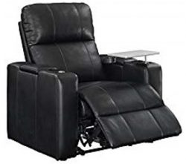

An awesomely, single unit chair of great quality. As you can see, it's made from a more comfortable leather than the one above and actually comes with a cup holder. Some reviews said it's a little sturdy trying to get the recline to work but over time it will become easier.

Pros:
- Comes with an outlet and USB charger as well as a storage compartment under the seats.
- Great for all heights and the power recline feature lets you tilt almost all the way back. Don't forget that it also comes with a swivel tray for snacks and anything else you need it for.
- The leather is soft and it's a great neutral black color for any setup. A lot of people liked its conservative design even though it has a lot of features that come with it.

Cons:
- You need two outlets to plug in this chair and use it to the fullest. One is for the chargers and one is for the power reclining chair. That sucks if you plan to get more than one of these in the same space.
- Most people were saying it's better to get an extension cord. You would just have to be a little innovative with how you line these up next to one another.

Seatcraft Grenada

$650 per seat
These seats are my top pick for sure. I embedded their promo video because they do a good job explaining their seat and its features. 4Seating.com is a website that I've recommended in some of my articles (non-sponsored) because they have a good selection of seats and customization options. If it was me I would use their website instead of searching Amazon since their site allows you to customize your order a lot more.
Pros: Awesomely durable and actually come exactly as they look. Tons of customization options for quantity and extra features like a wine glass caddy.
Cons: $650 per seat according to their site, you can order as a set of three and it calculates the. I haven't come across a review that didn't enjoy the seats. This makes sense because you definitely get what you pay for, which are high-quality chairs.

Divano Roma 2 Seater

$360
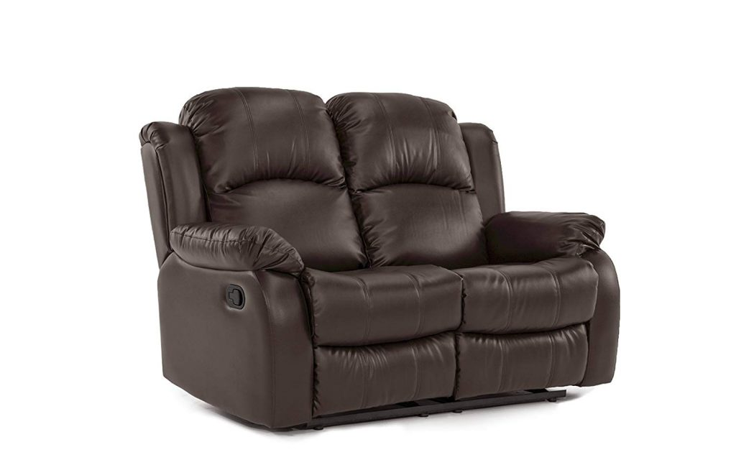
This one would save you money since it's not a power recline set. It's also good if you plan to upgrade in the future since the two set is on the more budget side. You can get a three seater version of this for $500. I think the set would be best if you already have some seats and just needed some good additional ones and aren't trying to break the bank.
Pros:
- Made from brown faux leather with a matt finish so your skin won't stick to it.
- The matt finish makes it more durable so kids and pets will have a hard time tearing up the furniture.
- Again, it's a good value for the price. It'll come with easy assembly (two 90lb packages that piece together).
- People liked how this one is comfortable enough to sleep in.
Cons:
- Legs hang a couple inches off the rest if you're taller than 5'11. It's really not that roomy for tall people.
- You also won't completely sink into the couch since it's more on the firm side.
- Since it's not power recline, you can't find an in-between recline setting. You would have to be legs all the way down or all the way up.

Madison Modern 2 Seater

$739

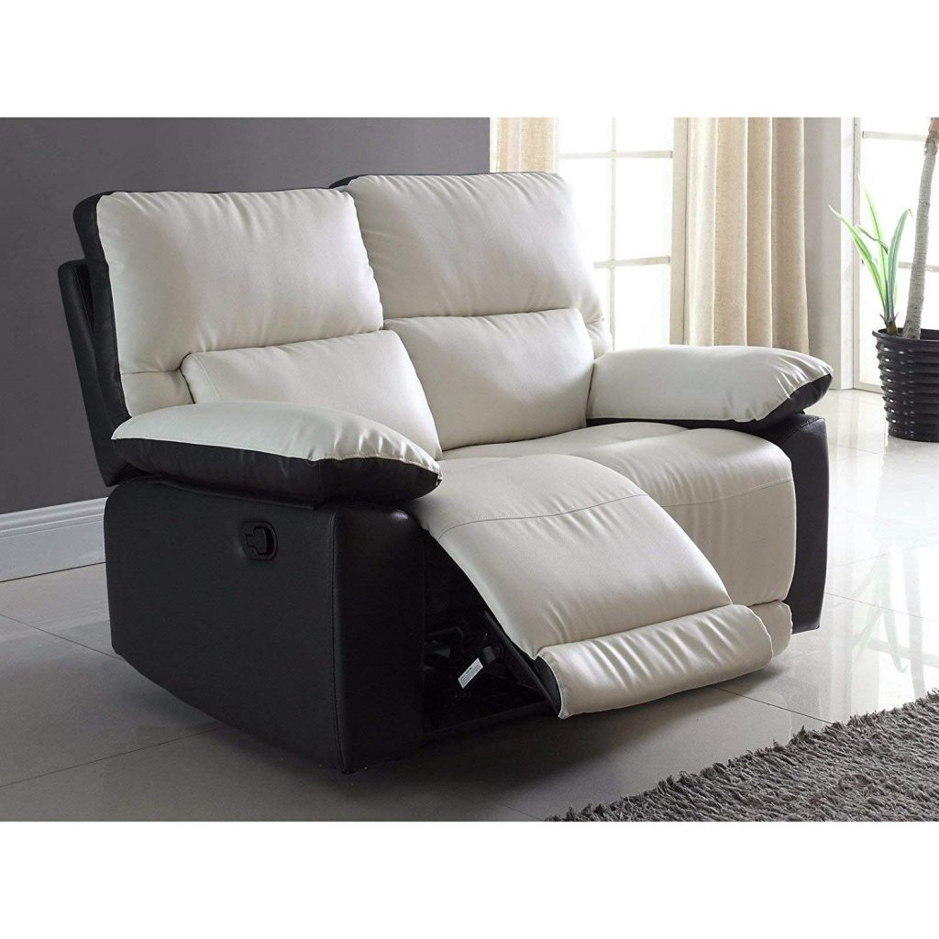
A more, unconventional alternative to textbook movie theater seats. While it doesn't have cup holders or snack trays, the price you pay for it is exceptional comfort.
Pros:
- Great for small spaces and can recline really far back.
- Built-in lower back support is a big plus for me since I'm tall and my back hurts easily from sitting long periods.
- You can try these out at most Walmart stores and it comes with really good warranty and delivery service.
- This product is exactly what you will expect it to be and as comfortable as it looks. Longevity and durability against pets and kids is also included with the good of this product.
Cons:
- Not super spacious if you're going for a more roomy feel.
- Color isn't actually a white but rather a light shade of grey.
- It also doesn't have cup holders so you would need a table or something to put snacks on instead of resting them on the couch somewhere.

$1000 - $2000

Flash Furniture Reel Series

$1000
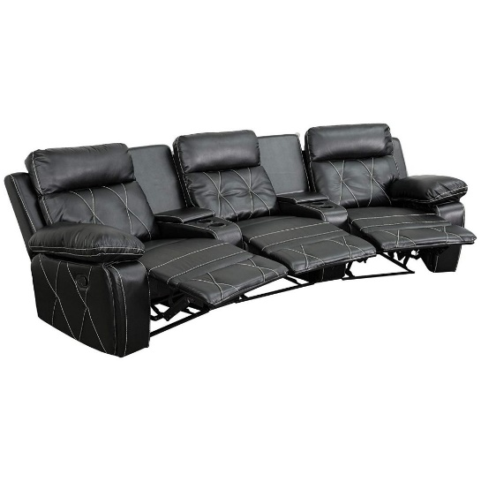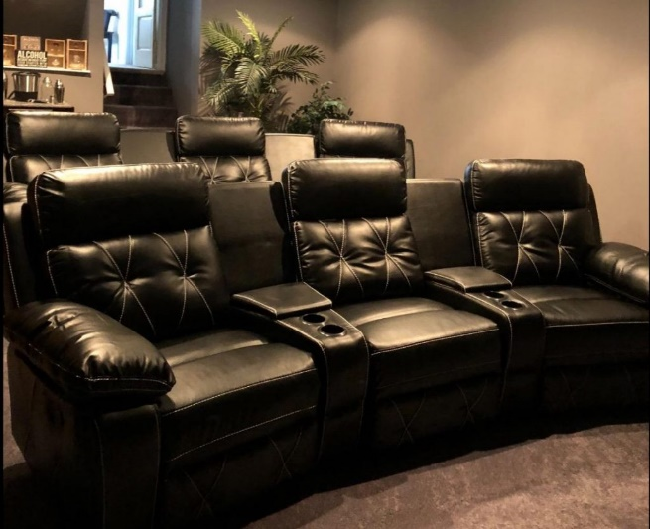
At first, I wasn't a fan of how prominent the white seams were but then the customer photo on the right actually did it justice. This set of three goes for just over $1,000! It's nice to come across good products that aren't insanely overpriced.
Pros:
- You could have a complete, 6 seater home set up for $2000. This set would be best if you need a lot of seats for a more affordable price.
- Even though this goes for about $350 per chair, people really like the comfortability of them, especially the headrest.
- Soft leather and gives you that big and squishy feel but you also won't feel inclined to fall asleep right away. For me, it strikes the perfect balance.
- Deep consoles allow for sufficient storage of remotes and cup holders are nice and big.
Cons:
- They aren't power reclining, so the recline lever is a little stiff when you first get it but with time it'll become easier.
- I honestly couldn't find other discrepancies with these chairs. For me, this is a win and I'm glad I wrote this article so I can come back and remind myself that this one is the best I've found when I build a home theater again.

Coaster 600 Set of 3

$1300
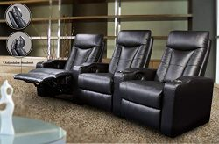
They're just as thick as the Flash Furniture series (above) even though the picture makes them look skinny. This one is also a big bang for the buck for several reasons.
Pros:
- These chairs will give an authentic and expensive feel even though they cost $1000 for a set of three. The soft black leather (not pleather) makes it comfortable.
- I would say this is mid-range quality given the price but still feels like you're getting every dollar you paid for.
- It's manual reclining features will save you an additional $900 which could be spent on another set of 3 if needed. Oh and they're really sturdy.
Cons:
- Takes some muscle and a second person to snap all the parts into place.
- It's more on the firm side, but if you don't like sinking seats then this won't be a con to you.
- Some people may not prefer how much the lower back tends to dip on when reclining back.
- I can see taller people having more of an issue with this if they're sitting in it for long periods of time. I also wouldn't try to sleep on these.

Seatcraft Sigma

$1900
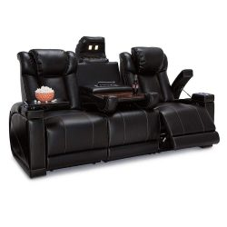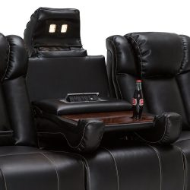
There's two in this article that look exactly the same! One is from Seacraft and the bottom one is Delange and I put both of these in here because they vary in price by about $600 and I'm not sure why. But both of them have received great reviews.
Pros:
- Power recline and features such as USB charging ports and arm storage.
- It's comfortable enough to take a nap in or do homework.
- The top thing that sticks out is a reading light or for any needed use.
- People like how the leather material doesn't heat up during the summer months.
Cons:
- More expensive than the other brand but they are essentially the same thing.
- You need 3 power sockets to make this thing turn on. This is a con for most power reclining chairs and you would need a decently sized transformer to make a bunch of seats work in one place.
- People note that it sometimes takes a quick second to power up when in use.

Delange Reclining Power Sofa

$1200
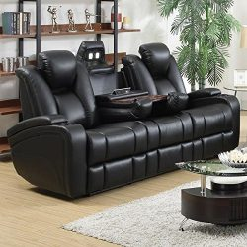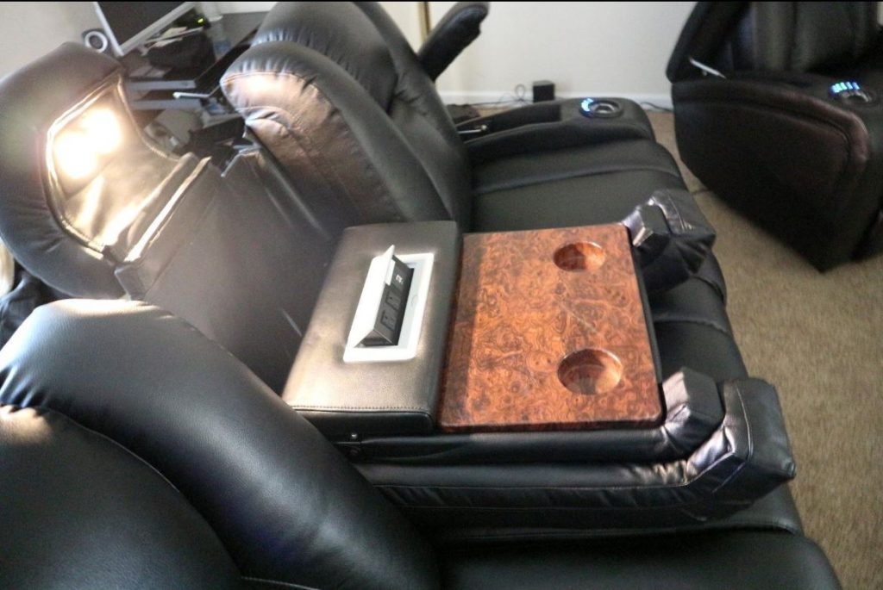
This is the cheaper model of the Seatcraft brand. Since this one is also power recline, I think Seatcraft just marked up their price because they are a dominating brand for home theater chairs. This one is from a different company but honestly, people love this product almost more than the Seatcraft ones.
Pros:
- Notable back support, powered headrest and the seats feel big and roomy.
- The smooth power recline makes little to no noise and all the controls are at the fingertips.
- Cushioning is more on the firm side. This one only needs two A/C outlets as opposed to 3.
Cons:
- Tray table is easier to damage and is more fragile. Maybe this company skimped a little bit on the tray table to save money.
- Buttons and lights can't be turned off but they're not extremely bright to begin with.
- This package is extremely heavy so I would account for that if you order online.

Octane Seating Mega XL950

$1600
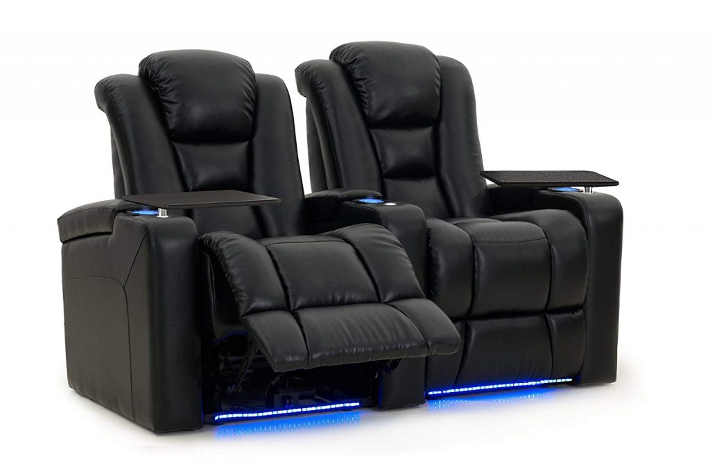
Sounds like a robot's name. $1500. They don't have an established page on Amazon but they do have a fancy looking website which shows they mean quality business. I couldn't find reviews on this one but check out their site (non-sponsored link) if you're interested in this design/look).
I put their seat in here because other authoritative articles I've looked at consider Octane Seating to be one of the top brands to buy high-quality chairs from. I can imagine the only con with them is that they're on the way expensive side.

$2000+
I swear I'm not sponsored at all by Seatcraft. They have no idea of my existence but I just couldn't stop coming across such highly rated chairs when I was researching so this section is 3/5ths dedicated to them without intention. Here's the best of their products:

Seatcraft Seville

$2100
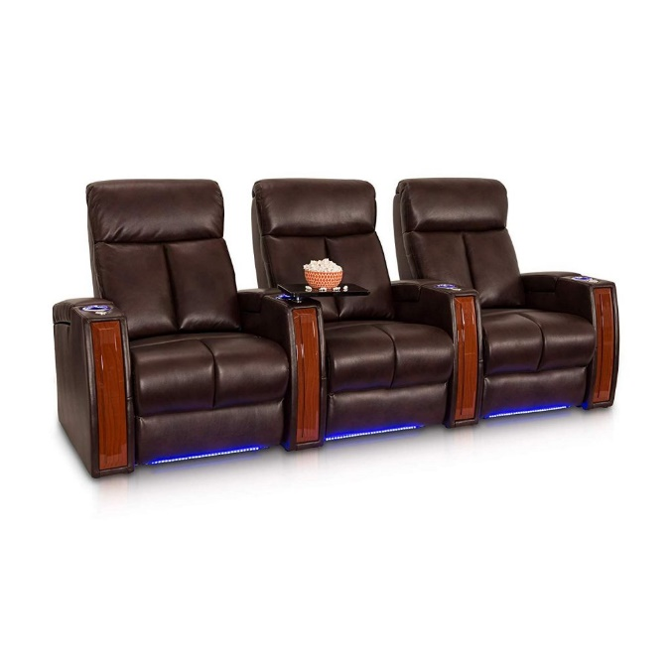
These chairs come exactly as advertised so you know exactly what you're paying for. The higher quality leather material is what marks up the price for this one as well as the woodwork. Other than those two qualities, they're just like every other seat so far.
Pros:
- Comfortable leather gel material and nicely polished woodwork design. You can get a set of two for under $1500 and it comes...again with USB charging ports (why does everybody like USB charging ports?)
- Cup holders light up so you won't lose it in the dark. Delivery service is awesome and more notable than the other chairs.
Cons:
- Like all other ones, you need a couple A/C sockets but that's all I could find on the dislike side. The only other thing about this one you'll notice is that the seats are more traditional and compact in their structure.
- If you like getting close to the person sitting next to you it would be hard to so considering you can't lift the middle armrests up...just food for thought.

Seatcraft Anthem Power Recline

$2200
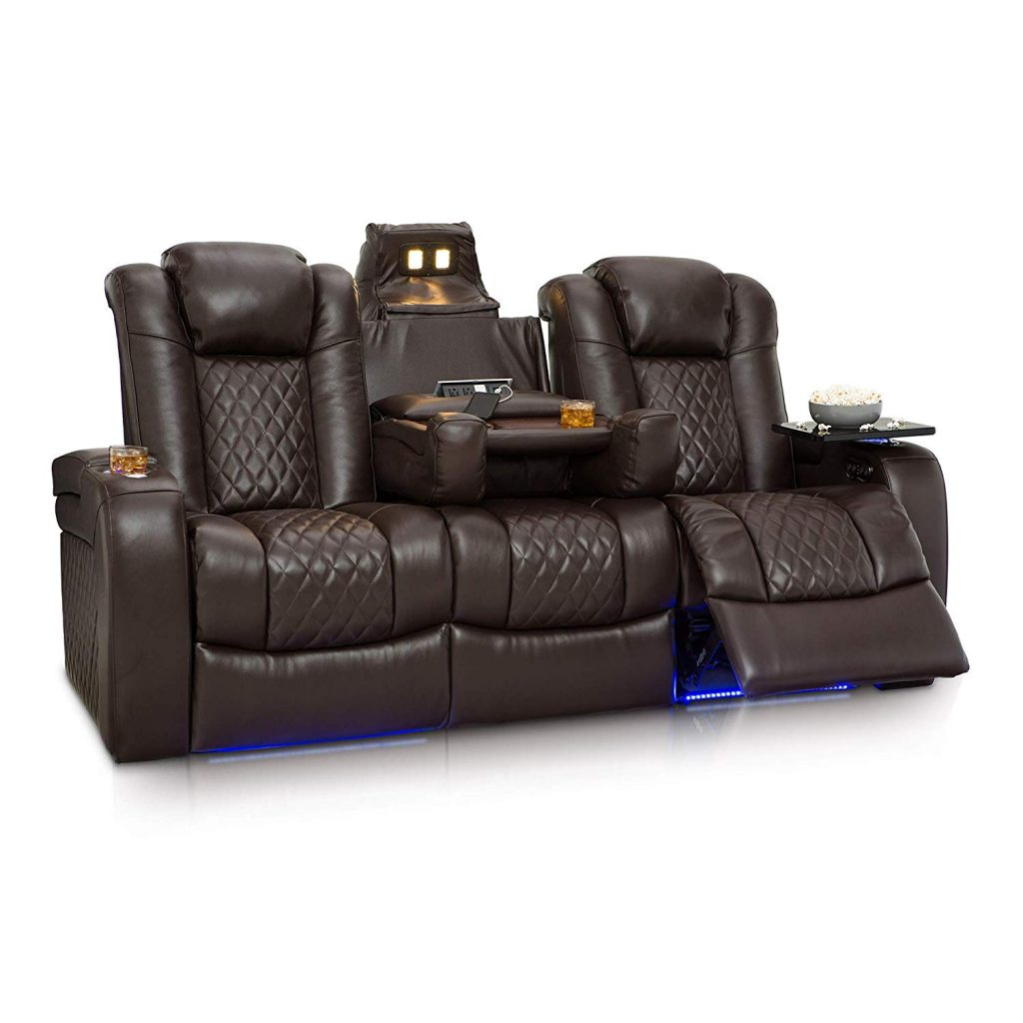
"Better than I imagined" was the most common comment on this product. It goes for $2200 for a two piece and this one is my next top pick. I'm so glad I came across these seats because I can see myself making the purchase in the future (when I get rich or something).
*You can flip the center console up and it turns into a third middle seat*
Pros:
- Top grain leather (best type of leather you can get), tray tables, and gentle glowing switch on/off LED cup holder lights are just the start.
- If you look at the top of the chair you'll notice that they also come with suitable reading lights that have been well-liked by reviewers
- Power recline adds to the price but for a set of two, this is a reasonably affordable price per chair.
- It can be described as providing "heavenly comfort," enough to where you can sleep on it (wouldn't recommend substituting it for a bed since it doesn't recline completely flat).
- Comes with a wireless charging pad! Trays can be popped on and off.
- A perfect example of something being better than you expected.
Cons:
- Weighs 500lbs (mostly all other chairs were only 300 and even that is heavy!).
- Arm naturally will want to rest on the tray table which is slightly higher than the outside rests.

Seatcraft Serenity

$2300
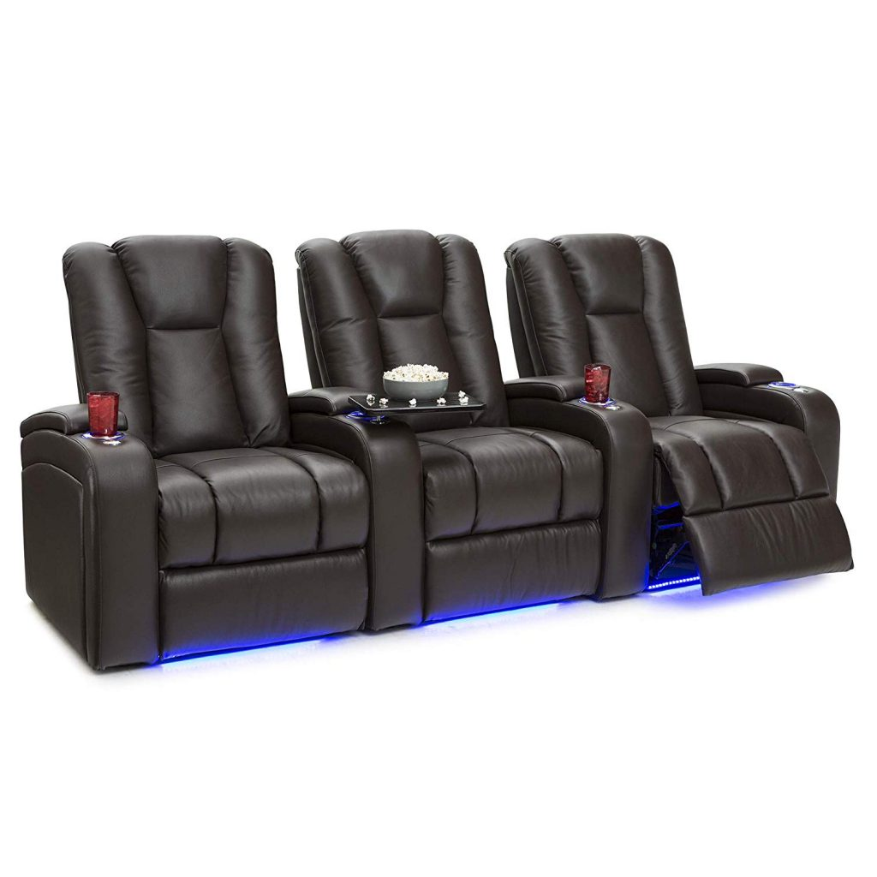
These ones look just like some of the other models with a few, better exceptions. Like most of their other brands, they are power recline.
Pros:
- If you really wanted to, you could get a set of two for $1500! They use hand selected leather with awesome touch and feel.
- Durability is a noticeable quality and it will always give you that "sink into the seat" feeling.
- You can also order it in various shades of black, brown, red or white to fit any set up.
- The tray table is uniquely removable compared to other models so you can take it to the concessions stand or kitchen if you needed to.
Cons:
- The seats don't actually attach to one another, but rather just slide next to each other.
- This means you can place them in any fashion you want but I think most people will just position them all next to each other like in the picture.
- Most people wouldn't want to freely move them around since they're extremely heavy.
- The various recline settings are nice but it doesn't take much to over tilt and not be able to see the movie theater screen.

Octane Seating

$2000+
Amazon doesn't have a dedicated section but I linked (non sponsored) to their site. This is the most premium site I found if you have a budget higher than $2000 for seats and accessories. You can get some pretty sweet accessories from them like stainless steel popcorn bowls that swivel around the armrests, aluminum tray tables, and cigar basins?!
I definitely think their brand is part of the markup price, but they definitely know how to cater to high ticket buyers and offer some really fancy, unique and comfortable chairs. You don't even have to use them for watching movies. If for some reason you need an industrial order of standard movie theater seats, these are also the right people to talk to.
This site lets you deliberately choose the type of leather material you want. I don't think it's all that important, but they offer Leather 9000, Bonded, Leather Gel, and Microfiber.

Other Resources to Find Awesome Chairs
Seatcraft: Obviously the star of this article. They really do run away with the competition. Their site is better than Amazon because they have more customization options for color and extra features like swivel trays. I've never contacted them, but knowing that they deliver expensive products, they probably can't afford to have poor service if you need to contact them
Elite HTS: If you're one of the big home theater enthusiasts and have a set up as cool as this sites cover photo, be sure to check these guys out. If you need exceptionally high quality chairs, have the coin for it, and want to fill a large room with them, this site is right for you. Check out their "Elite Extreme" gallery to get some inspiration.
Stargate: This site has all kinds of other home theater accessories including seats. They have some other off brand seats which look like knock off products to more expensive brands as well as accessories you wouldn't be able to find on Amazon. I've recommended their site when looking for decor items or even acoustic wall panels.
4Seating: This site is just like Stargate but mainly for seating (4seating get it?) What I also like about them is that they have a wide variety of seating options for sofas, couches, or any kind of lounging furniture that's not just for watching movies. If you don't want traditional home theater seats, check out their Multimedia Sections section

Conclusion
Hopefully this article is one you'll at least come back to for reference to get ideas as to what you're looking for. It doesn't have to be over complicated when it comes to considering what type of seats you want to watch movies with even though some may say otherwise. I tried to base these products off of common sense as to what would make a good movie theater chair without going too overboard on accessories. If you want to see more articles in the higher price ranges feel free to let me know but I've found that not much changes after a certain price point.
If you found chairs in this article that were way out of your price point, the sites from the resource section could easily have the same model for cheaper from a different brand or even with the option to remove accessory features. If you should remember one thing it's this: power recline should be the main deciding factor even though that's the biggest factor that affects price! Even though that feature lets you choose how far back to recline, I don't think most people would split hairs over how much they want it reclined or vice versa.
Again, if you have any questions or what to see something else feel free to leave a comment or reach out at entertainmentden.ns@gmail.com and I'll do my best to respond. Thanks for reading!

