Complete Buyers Guide to Gaming Equipment

Choosing a Monitor
- Response time under 10ms (5ms and under is ideal)?
- IPS Panel Type?
- Refresh Rate is 60hz or above?
- Aspect ratio is 16:9?
- Will your PC keep up with the specs if it’s above 1080p resolution?
*Monitors don’t need good speakers, getting some without them will save you $ to get a more dedicated sound system (i.e headphones, external speakers)
*Don’t hesitate to buy a monitor to just try it out with the expectation to return
Choosing a Mouse
- How well will it match the size of your hand? How do you want it to feel when you hold it?
- Does it come with weight adjustability?
- Is it easy to implement programmable features along with driver compatibility?
- Do you want to be able to change between smooth scrolling and wheelock scrolling?
*Consider getting a wireless mouse and a charging pad? (Logitech G903)
Choosing a Keyboard
- Membrane / Mechanical or Scissor Type?
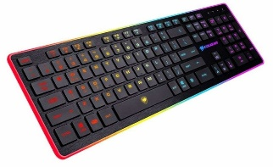
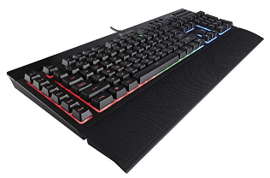
- How do you want the keys to feel when you press them?
- Can you program keys (macros) and is the software easy to use? Logitech’s keyboards are the easiest
- Have you looked into how useful keyboard macros can actually be?
Choosing Headphones / Speakers
- Will they be comfortable enough to wear for a few hours without making your head hurt / feel nauseous?
- Is the mic quality good enough for your needs? Mic cord easy to adjust if needed?
- Does it come with too many cords? It ideally should be simple and portable
- Good balance of bass and treble? You shouldn’t feel the need to adjust them
- Cancel out enough noise? How much do you want them to?
  - Most over the ear headphones already do a good job at that
*External speakers should accommodate your setup. If you don’t have a dedicated room, consider a soundbar or desktop speakers such as the Klipsch Promedia 2.1.
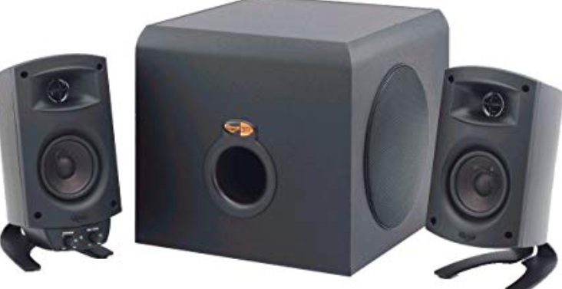

*Surround sound systems are possible if your motherboard supports 5.1 speaker units and you have the space for it

